CS3714 iOS Mobile Software Development

Semester Project Report

Fall 2018

**CityBike**

Xueting Feng, fairyfxt@vt.edu

Zhiyuan Li, lzy9667@vt.edu

Thoang Tran, tthoang@vt.edu

Department of Computer Science

Virginia Tech

Blacksburg, VA 24061

*Date:* 10/25/2018

*Team Number:* Group 1

*Instructor:* Dr. Osman Balci

**EXECUTIVE SUMMARY**

**List of Implemented iOS Features Learned** (At least 3 required per team member)

1. **JSON Data**: Obtain JSON data from an API and process it
2. **Keyboard**:
   1. Remove keyboard by touching anywhere on the view's background
   2. Scroll up the entire UI content to show a Text Field hidden under the keyboard
3. **Maps - Apple API** (MKMapKit)
   1. Create and display a polyline on a map showing a track consisting of geo-locations
   2. Determine and show user's current Location
   3. Forward Geocoding
   4. Get Driving or Walking directions from one coordinate (latitude, longitude) to another and show it on map with a polyline
   5. Show Standard map
4. **Maps - Google API**
5. **Navigation Bar**
   1. Create and change buttons on the Navigation Bar programmatically at runtime
   2. Fit long titles in multiple lines within the Navigation Bar
6. **Pass Data to an Upstream View Controller**
   1. Using the Unwind design pattern
7. **Property List (XML) Files:**
   1. Read from application's main bundle
   2. Read from a server computer over the network
   3. Read from and write to documents directory on the iOS device
8. **Search Bar**
   1. Create a Search Bar at runtime just above a Table View
9. **Tab Bar**: Tab Bar-based Navigation
10. **Table Views**
    1. Custom-built table view rows (cells)
    2. Color alternate table view rows for clarity of display
    3. Sectioned Table View
    4. Indexed Table View
    5. Move rows within a section in a table view

**List of Implemented New iOS Features (**At least 1 required per team member)

1. **Touch ID:** Allow users to use the Touch ID to login the app
2. **3D Touch**: Allow users to use the 3D Touch to view details
3. **Collection View**: display photos in a Collection View, enlarge selected photo, and rearrange photo location in the Collection View.
4. **Speech to text conversion:** In the search view and add view, we allow users to input the information by speech.
5. **Store photos in Document Directory:** Enable user to take a photo or video, store it into, and retrieve it from the app's document directory on the iOS device.

**TABLE OF CONTENTS**

1. SOFTWARE LIFE CYCLE 5

2. OUR OBJECTIVE 5

3. PROBLEM SPECIFICATION 6

3.1 What is the problem? 6

3.2 Why is the problem important to solve? 6

3.3 Expected Functionality Description 6

3.4 Learned and new iOS features to be implemented 7

4. REQUIREMENTS SPECIFICATION 9

4.1 Functional Requirements 9

4.2 Non-Functional Requirements 9

5. ARCHITECTURE SPECIFICATION 10

6. DESIGN SPECIFICATION 11

7. DELIVERED SOFTWARE FUNCTIONALITY 17

8. STEP-BY-STEP INSTRUCTIONS FOR DEVELOPING NEW FEATURES 43

8.1 New Feature 1: 3D touch on Cell 43

8.2 New Feature 2: Collection View 43

8.3 New Feature 3: Take a Photo, Store, and Retrieve it from the Document Dictionary 47

8.4 New Feature 4: Biometric ID 49

9. CONCLUSIONS 49

10. SUBMISSION INSTRUCTIONS 51

11. PERCENTAGES OF CONTRIBUTION 52

12. CALCULATION OF GRADES BASED ON PERCENTAGES OF CONTRIBUTION 53

13. TEAM PROJECT REQUIREMENTS 53

14. GRADING SHEET 54

# SOFTWARE LIFE CYCLE

A good software engineer develops software by following the software life cycle shown below.

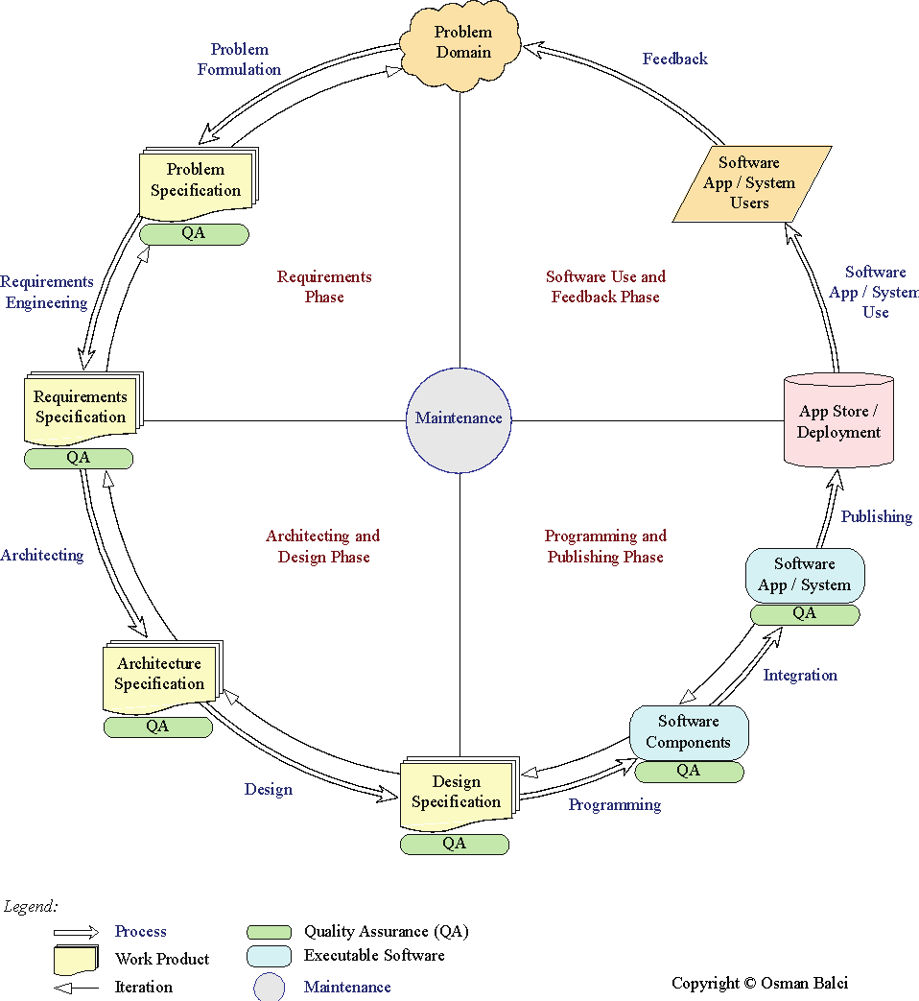

A programmer (hacker or ad-hoc developer) develops software by looking at the problem and directly coding in an IDE. This approach is known as the *Build-and-Fix Approach*, which must never be used!

# OUR OBJECTIVE

The objective of our iOS team project is to **demonstrate how capable the team members are** in engineering an iOS app to solve a problem. The app is created for the purpose of showing how *learned* and *new* complex functionalities and iOS features the team members are capable of developing. The objective is **not** to develop an app for publishing it at the App store.

# PROBLEM SPECIFICATION

## What is the problem?

Imagine when you plan travel somewhere around the busy cities such as New York, it’s often difficult for tourists to get around by cars due to heavy traffic and lack of parking spaces. Frequently, tourists must rely on public transportation such as bus, metro/subway trains to get from place to place. Recently, visitors to a city can have another option: rental bikes. This is a great way to get around the city and to do some sightseeings at the same time. In order to get a rental bike, people need to know some information about rental bike stations, and bike availability at such bike station, or if there is any empty slot to return a bike back. Furthermore, after getting a bike, they may also want to know the bike routes or bike-friendly streets so they can go from one place to another place safely. We think there is a need to develop an app that provides necessary information to help tourists can travel around a city with a rental bike conveniently.

## Why is the problem important to solve?

There are several benefits provided by the app. The first one is that the app provides users with information about rental bike stations in a particular city so that users can plan ahead for their travel, especially how they can move around the city; and if they decide to use rental bikes, the app also provides locations where they can take or return a rental bike, etc. Secondly, the app also gives users an easy way to access detail information about bike stations nearby them, such as the number of available bikes, or the empty slots for returning bikes, etc. This information helps users make decision before they go to a particular bike station. Moreover, the app also provides functions that allow users keep track their rental activities so that they can look at it later for their reference in next trips.

## Expected Functionality Description

1. List all countries and cities that have available bike rent information for users to choose
2. After getting the specific cities selected by users, the app will require to get the geolocation of users and display all the nearby bike-rent station information. For example, the distance from the users’ location to the rent station, the address, the free-slots and the free bikes information.
3. Providing the bike route map and calculate the distance and time between two geolocation.
4. Get the heart rate (from Health) and record the riding route, time and duration for users.
5. Save every rent activity and providing the suggestions to users based on their geolocation and previous activities.
6. Allow users to take photo of the rent station, the app can recognize the geolocation from the photo. Also, users can share the photo and geolocation to their friends in the app.
7. Store and display all photos in the collection view, and sort them based on time or geolocation.
8. Develop a shortcut for this app that can make it more convenient to use.
9. Enable users to save the files and images to their devices and share to others.
10. Allow users to search the rent station based on the company, free bikes, free slots and the distance.

## Learned and new iOS features to be implemented

|  |
| --- |
| **1. Learned iOS Features Requirement:** Each team member is required to implement at least 3 learned features. A *learned feature* is defined as the one that is covered in the course tutorials and assignments. Click the hyperlink below to see a list of iOS features learned in the course.  [iOS Features Learned](https://manta.cs.vt.edu/cs3714/StudentsOnly/Project/iOSFeaturesLearned.html)  **2. New iOS Features Requirement:** Each team member is required to implement at least 1 new feature. A *new feature* is defined as the one that is **not** covered in the course tutorials and assignments. Click the hyperlink below to see a list of potential new iOS features to implement.  [New iOS Features](https://manta.cs.vt.edu/cs3714/StudentsOnly/Project/NewiOSFeatures.html)  **3. Complexity Requirement:** A *learned* or *new* iOS feature implemented in your team project app shall be judged with respect to its complexity and programming difficulty in determining your project grade.  **4. Time Requirement:** The following is the **minimum** time required to spend for the project.   * 6 hours per week x 4 weeks = 24 hours per team member * 24 hours per team member x 3 team members = 72 hours   The submitted project shall be judged based on the **minimum** 72 hours required in determining your project grade. |

Our proposed app shall implement the following *learned* and *new* iOS features.

**Table 1. List of Learned iOS Features to be Implemented**

|  |  |
| --- | --- |
| *No.* | *Description of the Learned iOS Feature to be Implemented* |
| 1 | Create Global Data and use it |
| 2 | Property List (XML) Files |
| 3 | Using the Delegation and Uwind design pattern |
| 4 | Ask for user's permission to access the iOS device's camera and location |
| 5 | Remove keyboard by touching the view's background |
| 6 | Storage and Retrieval of User-specific Data by using property list (XML) files |
| 7 | Obtain JSON data from an API and properly process it |
| 8 | Custom-built table view rows |
| 9 | Show a web page using Apple's WKWebView |

**Table 2. List of New iOS Features to be Implemented**

|  |  |
| --- | --- |
| *No.* | *Description of the New iOS Feature to be Implemented* |
| 1 | Obtain the geolocation from the meta data contained in a taken photo file, mark the location where the photo was taken on a map, and show the photo by tapping its map annotation. |
| 2 | Obtain the data from apple Health interface |
| 3 | Use Collection View. For example, display photos in a Collection View, enlarge selected photo, and rearrange photo location in the Collection View |
| 4 | Enable user to take a photo or video, store it into, and retrieve it from the app's document directory on the iOS device. |

# REQUIREMENTS SPECIFICATION

This section specifies the Functional and Non-Functional Requirements under which the iOS software application will be developed.

## Functional Requirements

1. “The user of the software system shall be authenticated with a Touch Id or Face Id. The user must set up gesture id before login, and after the gesture password is approved, the system will active biometric authentication.”
2. “The software system shall enable the user to use 3d touch function on table view. When the user force touch a cell of the table, the user should have a preview of the content.”
3. “The software shall present the user a list of cities that support rental bike location check.”
4. “The software shall present the user a list of rental bike locations at rental view page.”
5. “The user shall be shown the detail information when they click a certain bike rental location and then the user shall be able to open map and be guided to that location.”
6. “The user shall be able to add new rental bike information which is not include by our App by click the “+” button at the top right corner of bike location table view”
7. “The user shall be able to choose different map type: “standard, hybrid, satellite” when they want to be navigate to the nearest bike rental location”
8. “When the user is using our navigation function, their routine shall be recorded by our app, and the software system shall draw their path simultaneously on the map.”
9. “After the user arrived destination, our app shall be able to calculate the total distance the user traveled and the software system shall be invoke the iPhone Health App to calculate the total energy consumed.”

## Non-Functional Requirements

1. The software shall be able to match high privacy requirements to protect the users data and personal information.
2. The software shall be developed using royalty-free software products.
3. The time the software spent on retrieve data from internet shall be no more than 6 seconds.
4. The software shall be executable on any iOS devices that have the version lower than iOS 12.0
5. The software shall prevent to save any of the user’s personal information and upload to anywhere else, and the software shall not use the user’s personal information for any kinds of commercial usage.
6. The software shall be able to keep the user interface as simple as possible in order to let the user can quickly find the function or information they need.
7. The software shall not integrate any functions from other App, for example, use the navigation functionality from Google Map.

# ARCHITECTURE SPECIFICATION

We are using two different API:

**+ City Bikes API:** [http://api.citybik.es/v2/networks](http://api.citybik.es/v2/networks/network_id)

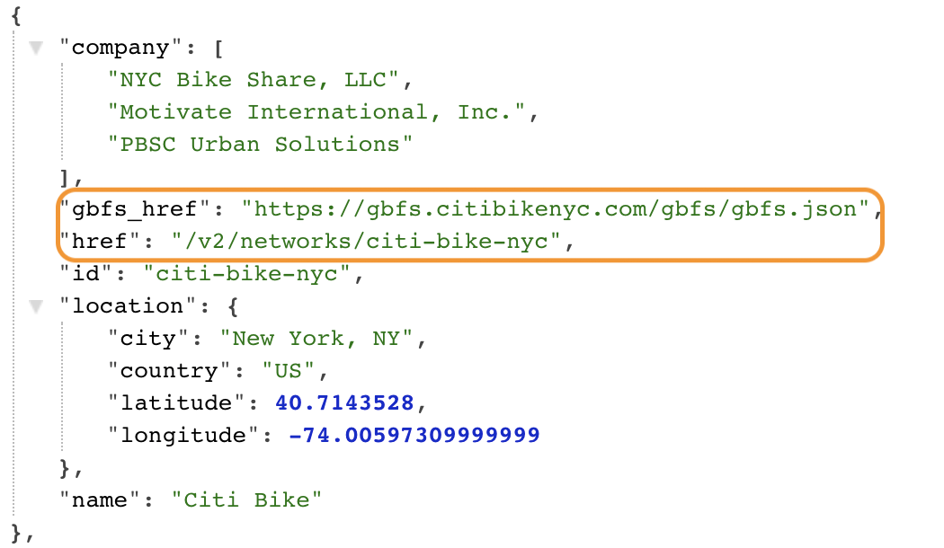

**+ Coord API: to search bike stations by the input address**

https://api.coord.co/v1/bike/system?latitude=40.74286877312112&longitude=-73.98918628692627&radius_km=0.5&access_key=<your_api_key>

# DESIGN SPECIFICATION

1. **HomeViewController:**

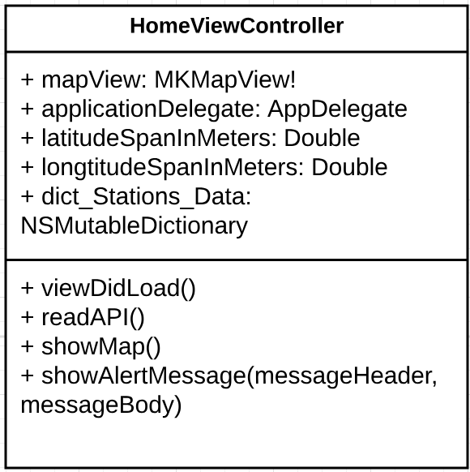

1. **Search Bike Station:**

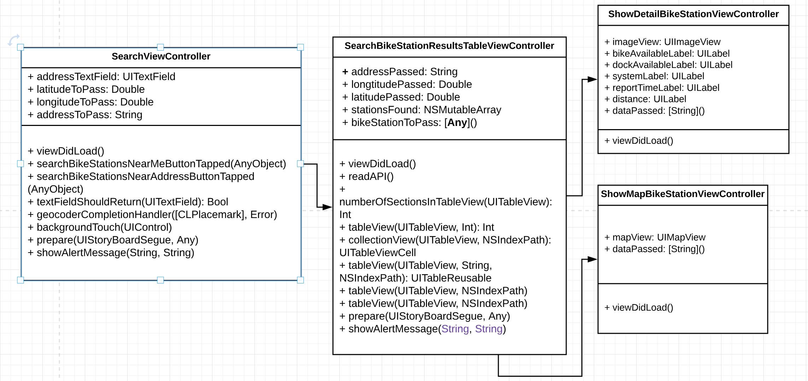

1. **Photo Library**

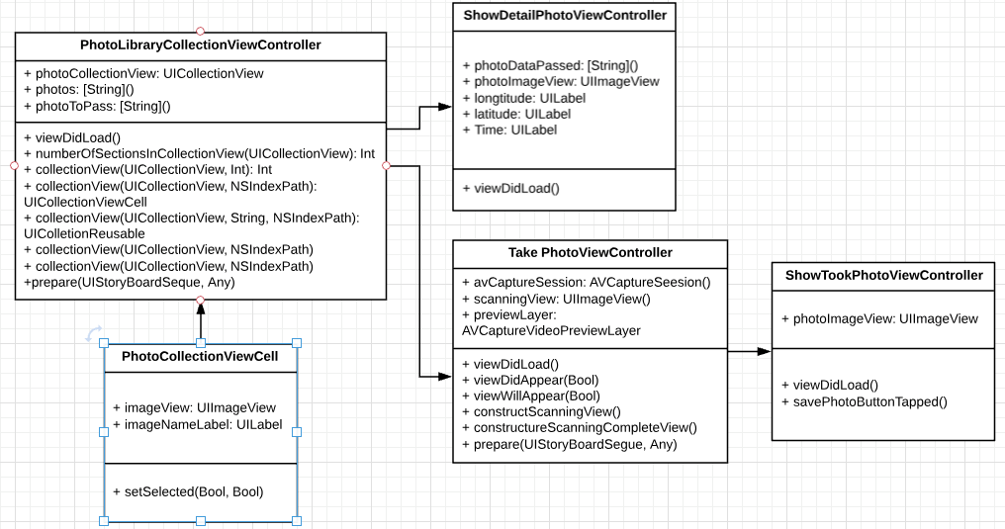

1. **Authentication cycle UML**

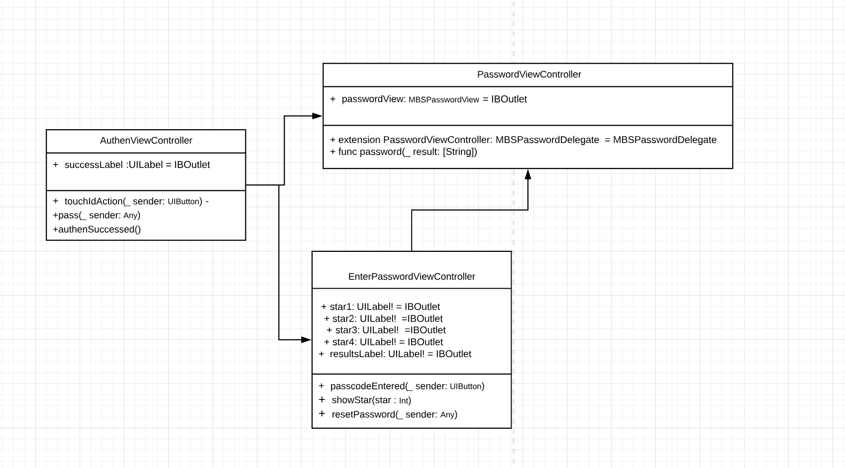

1. **Cities Table View**

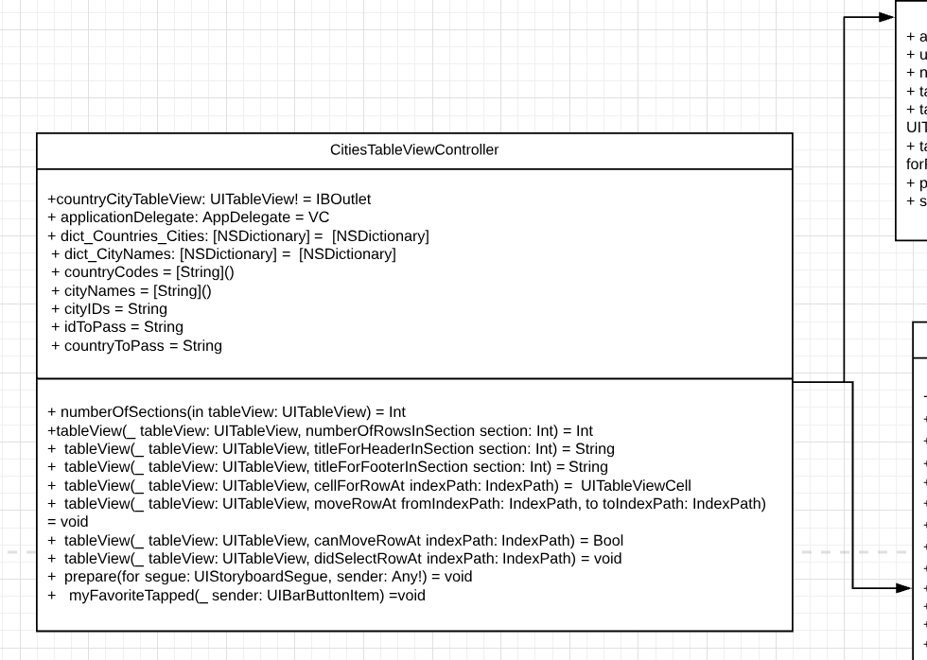

1. **My Favorite View**

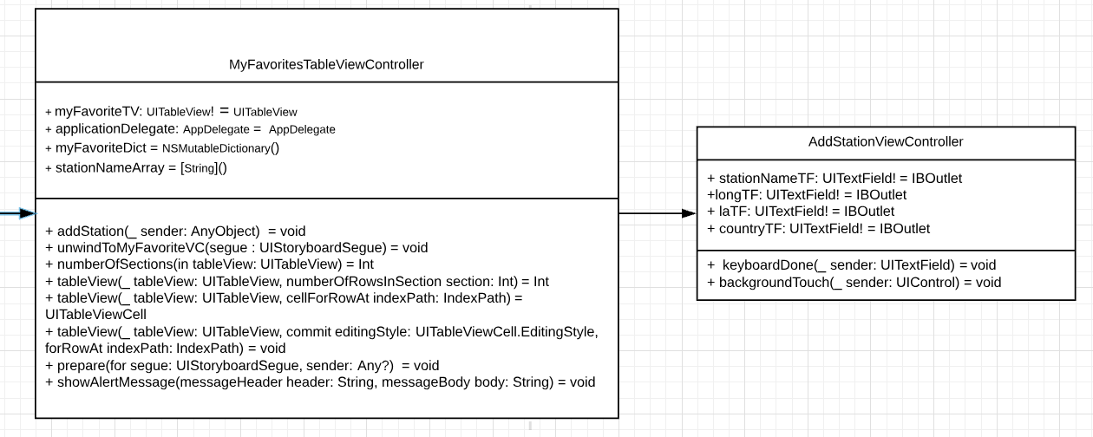

1. **Station Table View**

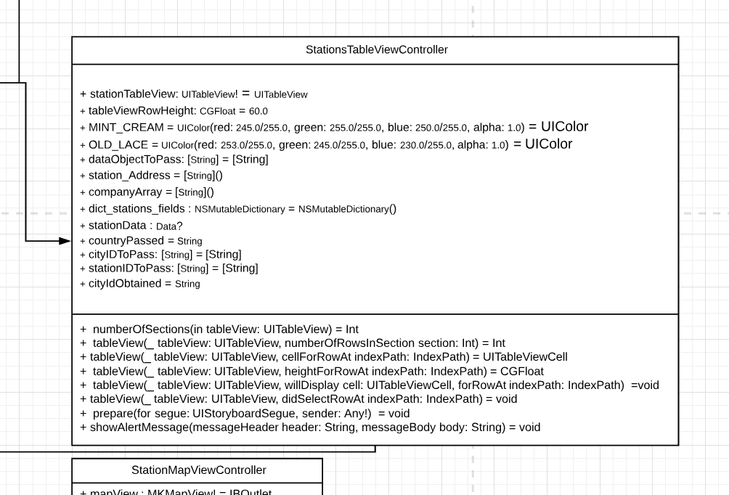

1. **Details and Station Map View**

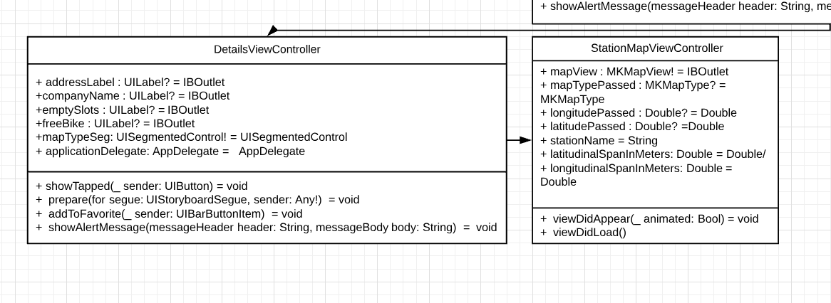

1. **Overall Structures:**

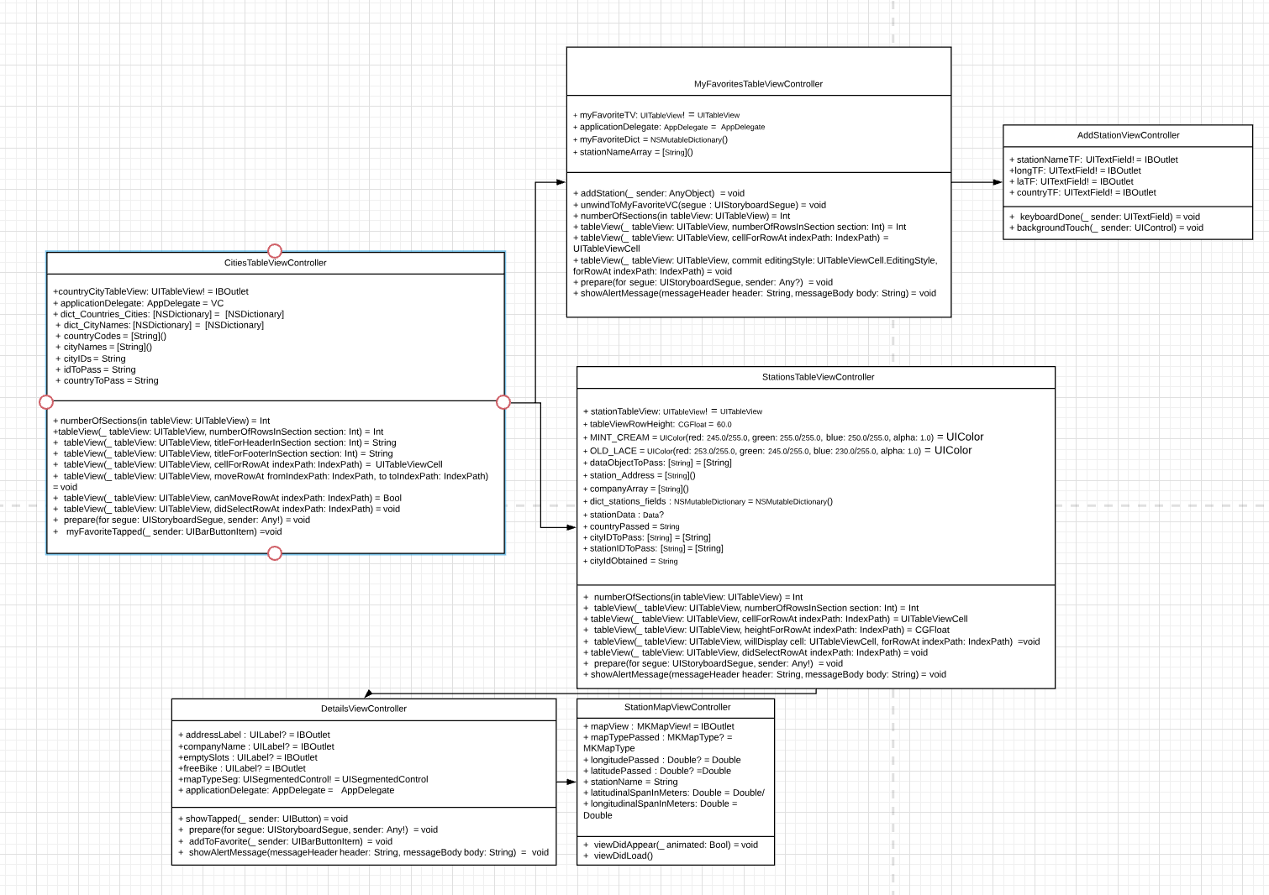

**No credit will be given for a UML diagram that is not readable!**

# DELIVERED SOFTWARE FUNCTIONALITY

**1. Login Authentication**

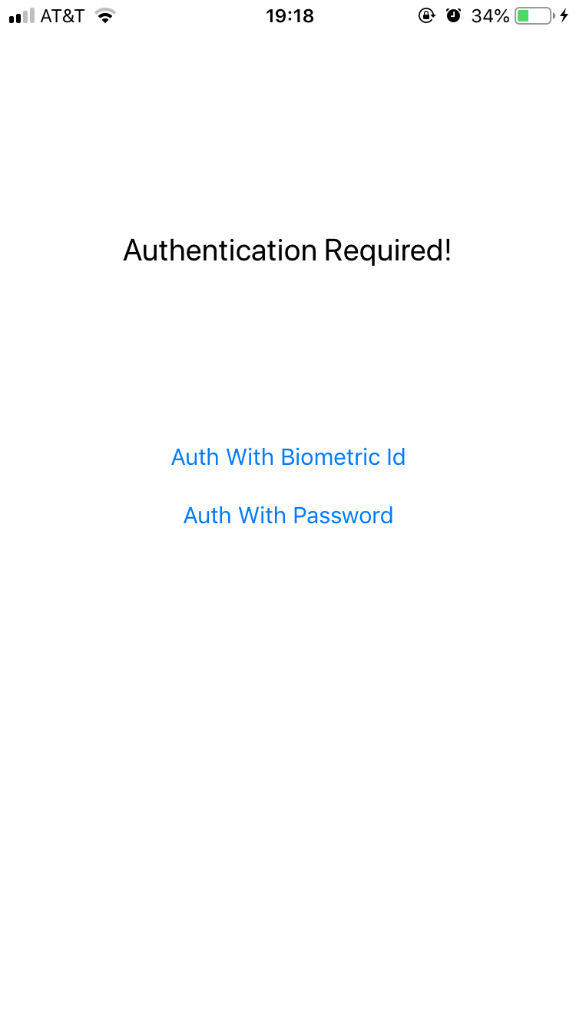

When the user launch the app, the first view the user see the authentication page. There are two ways of authentication. Biometric Id and Password. For iPhone X, iPhoneXS, iPhoneXR, and iPhone XS Max we will use the FaceId, for iPhone devices that has Touch Id, the system will authenticate by Touch Id. For devices that does not support biometric authentication we designed Password authentication.

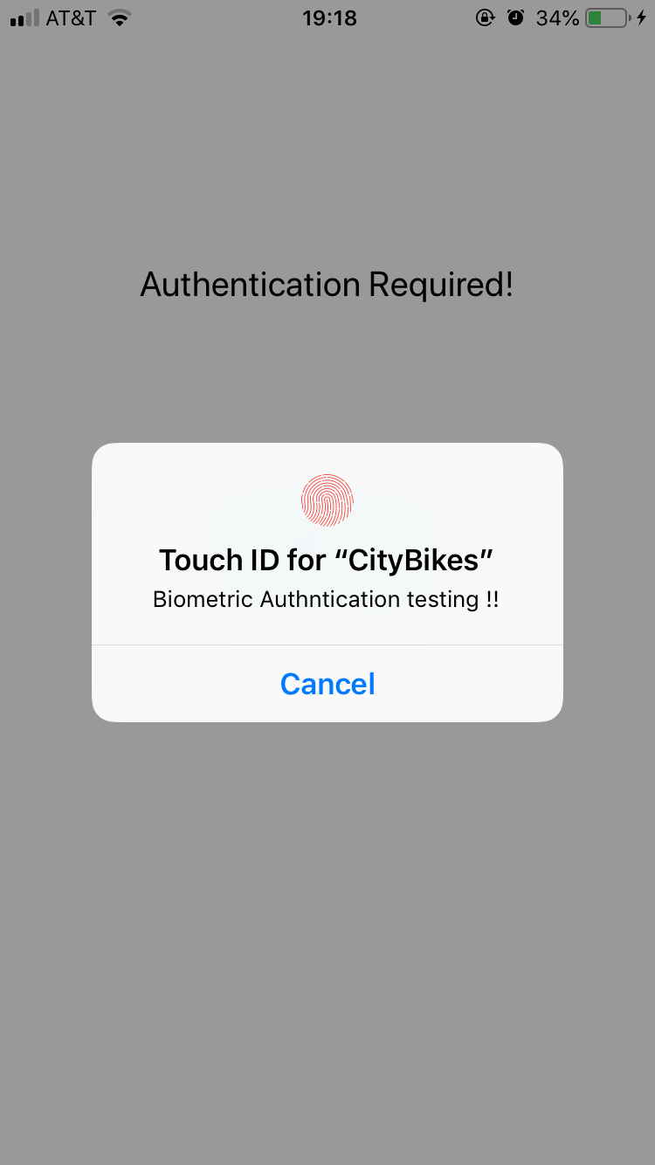

Once the user click biometric authentication, the Touch Id or Face Id authentication page will automatically shows up.

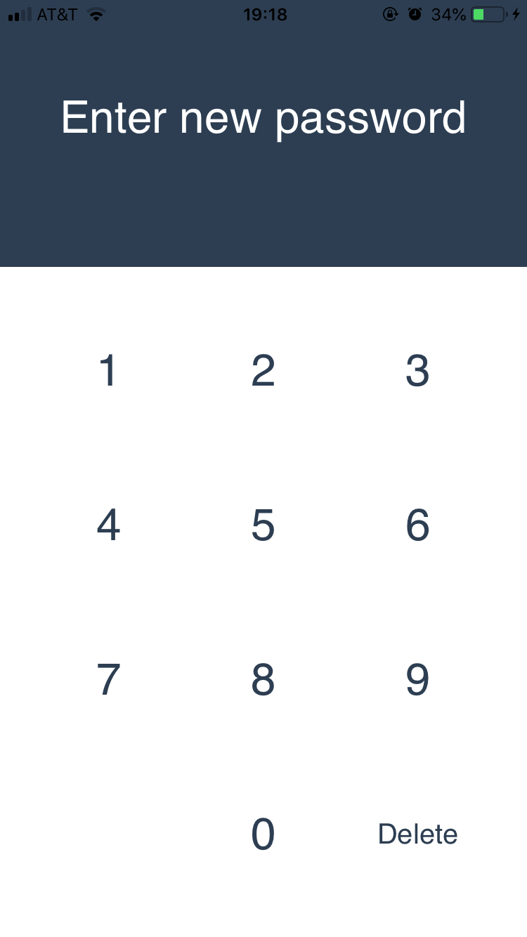

If it is the first time the user lunch the app, the system will guide the user to the create-password view after they chose authenticate by password.

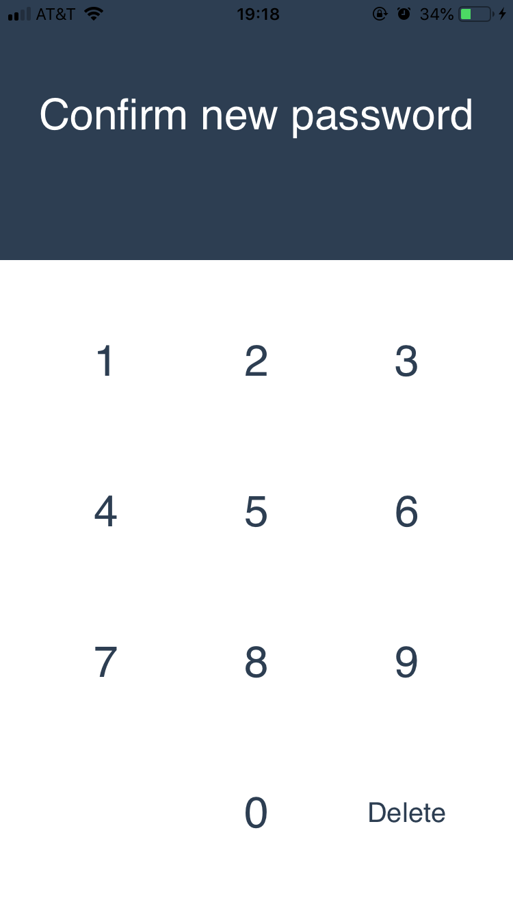

After the user set his password, we require the user to confirm the password.

If the user successfully confirmed the password, he will be guided to the home screen.

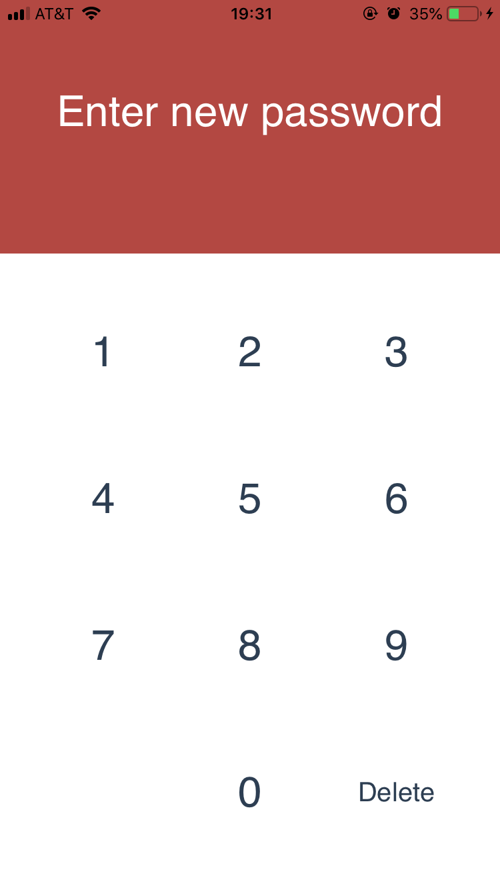

If the user failed to confirm the password, the screen will shaked and turned to red background color to indicate the user the password is wrong.

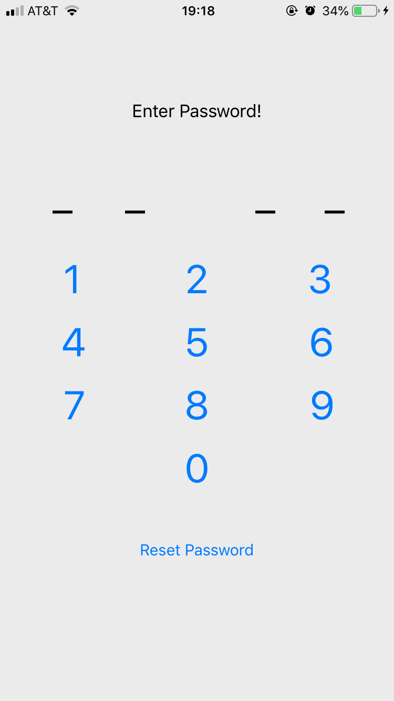

If it is not the first time the user launch the app after he chose authenticate by password. The user will be guided to enter-password page. If the user successfully entered the password, he be get in the home screen.

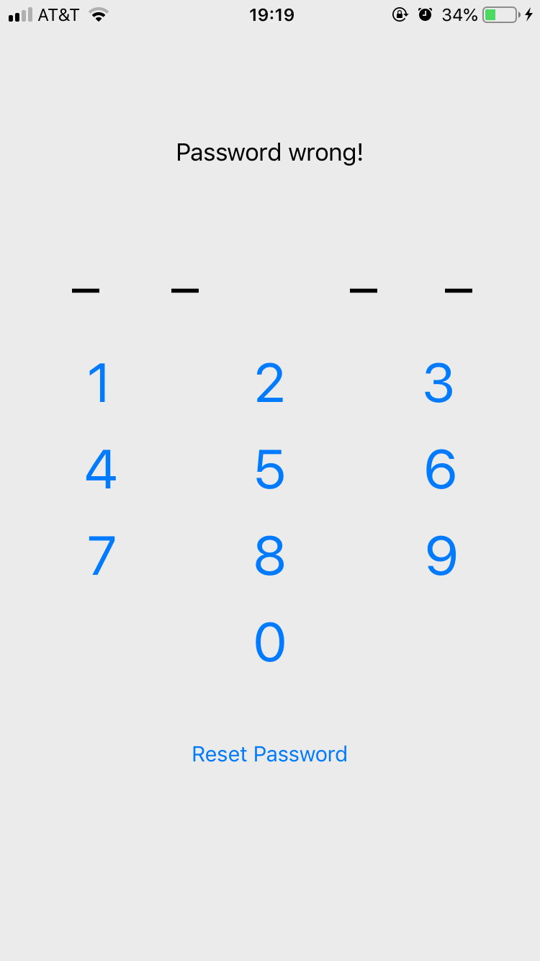

If the user enters the wrong password, the text will indicate wrong password.

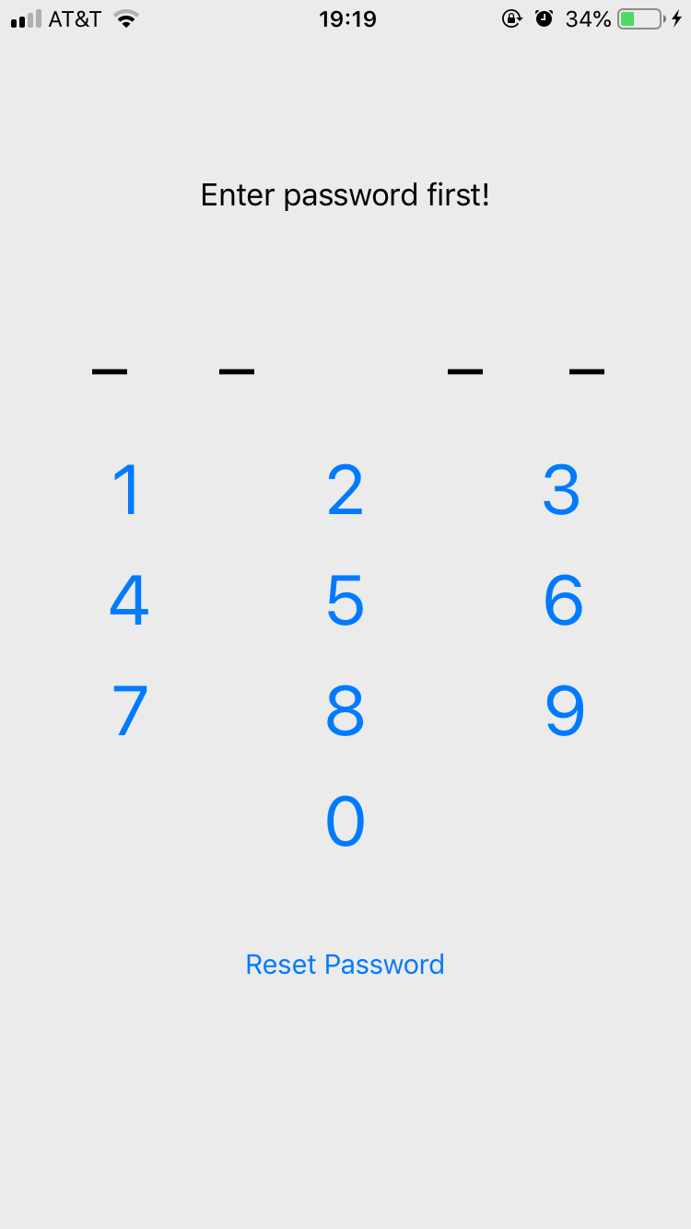

If the user clicked reset password button, he is required to enter correct password first for security reason. After the password confirmed, the user will enter create-password view.

**2. Home Screen**

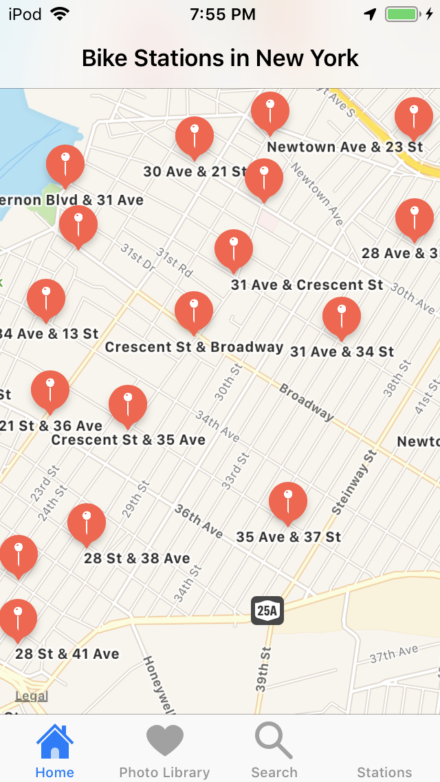

(1). Home screen will show bike stations in New York

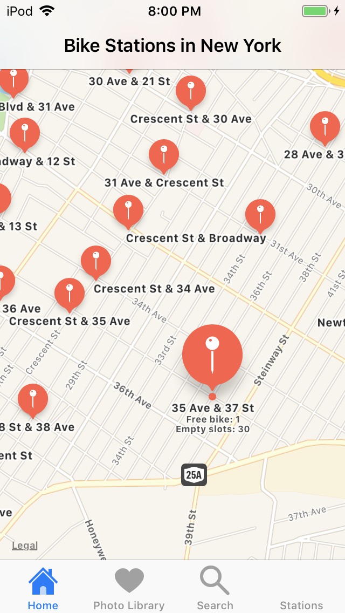

(2). When users tap on the location pin, the number of free bike and empty slots will be displayed

**3. Search Bike Stations**

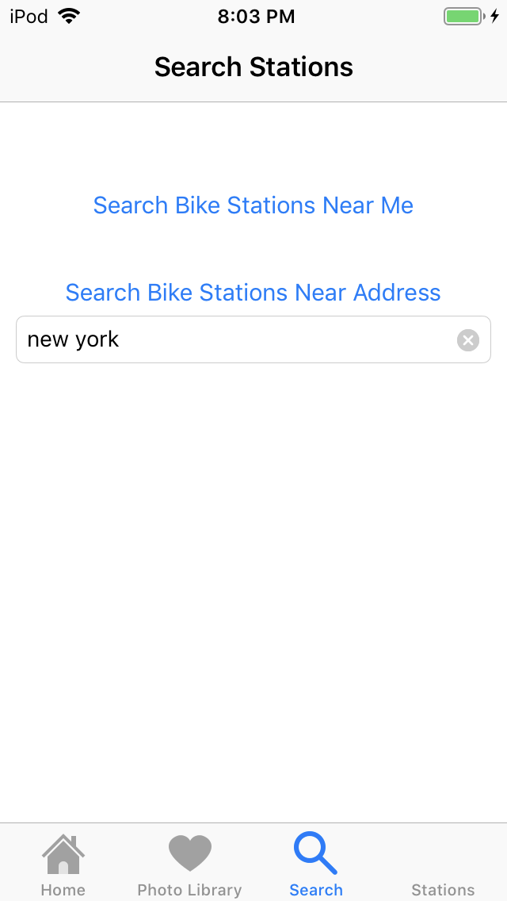

(1). Search screen provides two buttons that allow users to search bike station near me or search bike stations near the specific address. The Search Stations provides results from the Coord API.

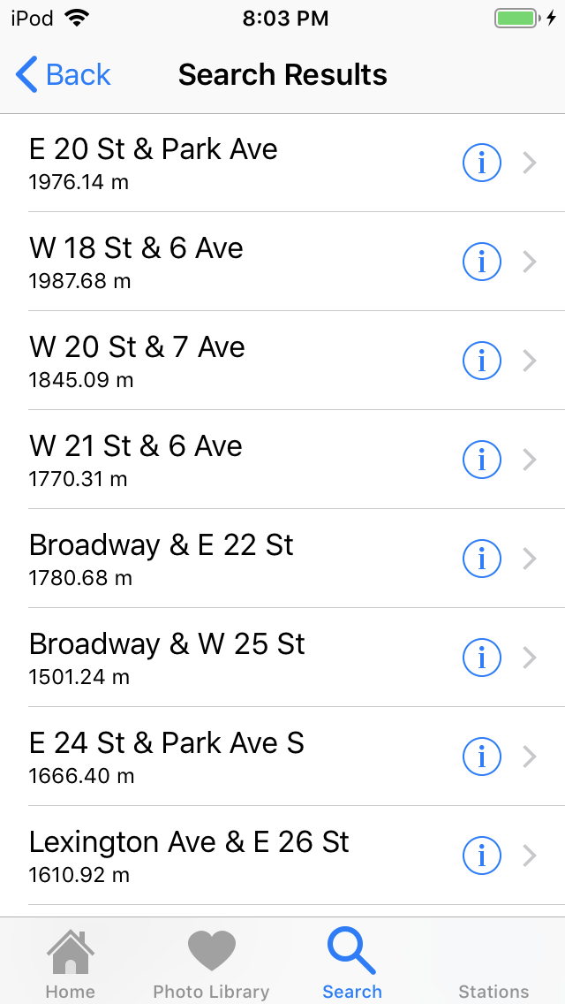

(2). Search results are listed as shown above by using the data returned from the Coord API.

* If users tap on the row, the bike station details will display on the screen shown below (2.1).
* Tapping on the Detail Disclosure button in the Search Results shows the map of the selected bike station (2.2).

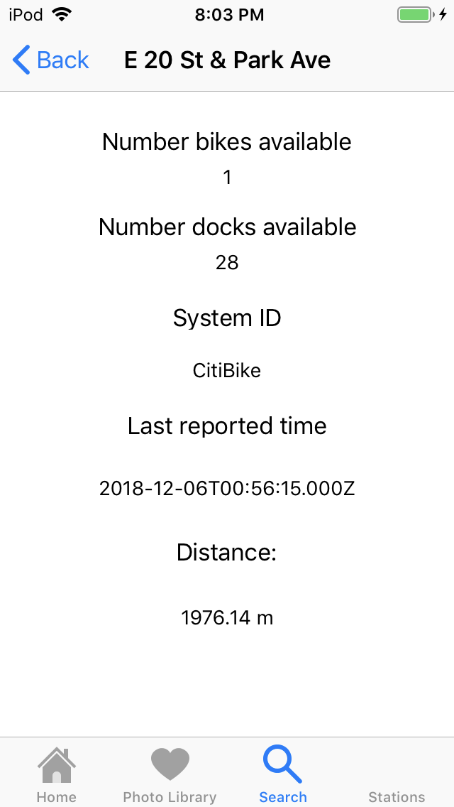

(2.1). This screen shows the details of the selected station on the Table view and the computed distance between two places.

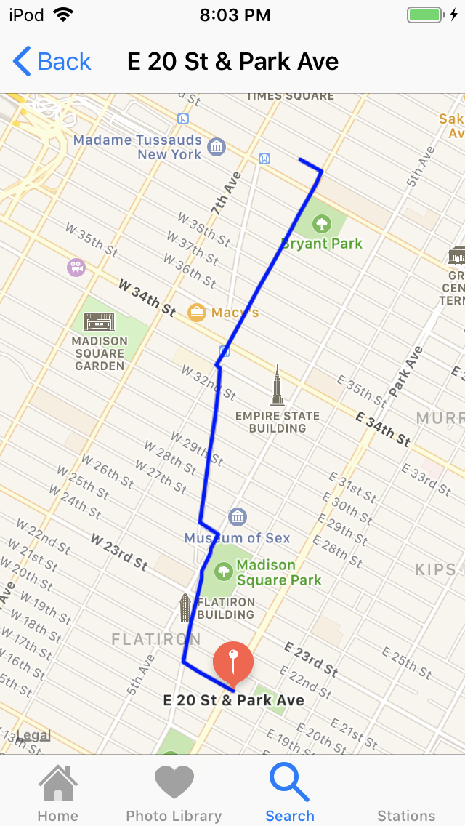

2.2. The screen shows the map and the walking travel path between two places on the map.

**4. Photo Library**

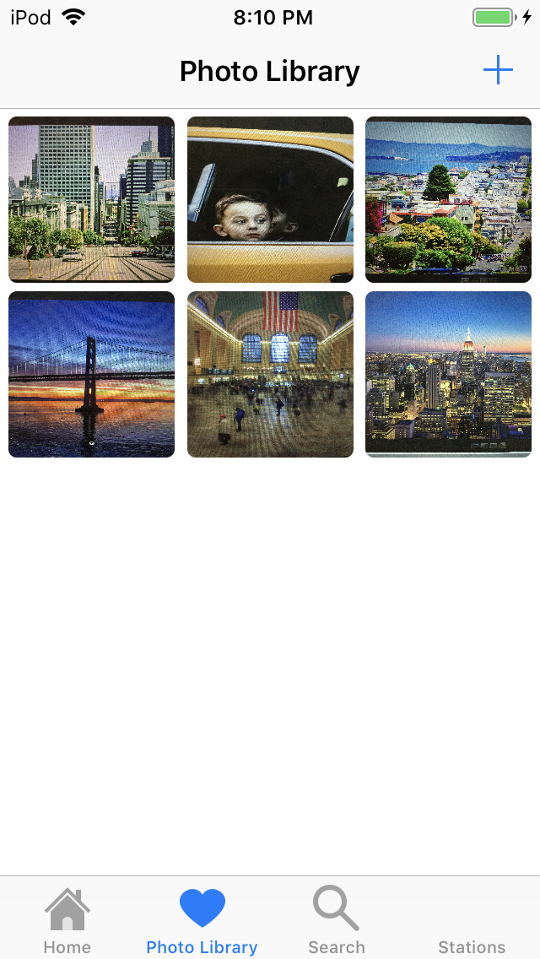

(4). The screen provides Collection View of photos.

* User are able to rearrange photos by clicking and holding the photo and dragging the photo to the desired location.
* Users are able to Add new photo by tapping on “+” button (4.1).
* Users are able to view the larger photo by tapping on the photo (4.2).

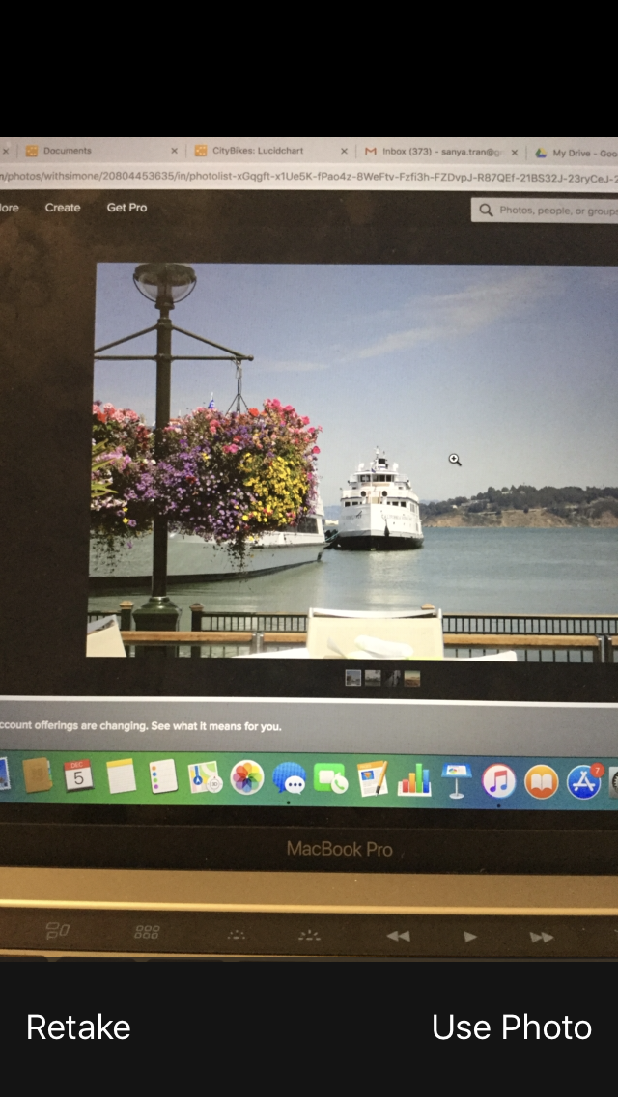

(4.1). By tapping on “+” button, the app will open a camera and allow user take a picture. And then, tapping on User Photo button to save a photo or tapping on Retake button to retake a photo. When users tap on Use Photo button, the below screen will be shown (4.1.1)

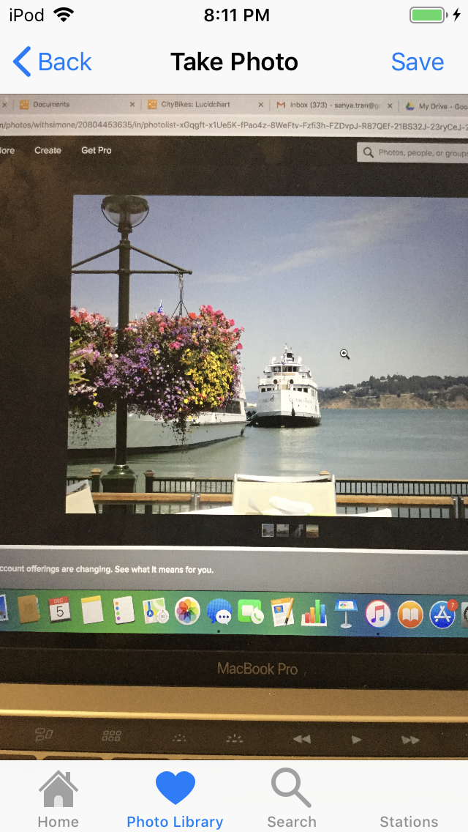

(4.1.1). Users tap on the Save button to save a photo. When users tap on Save button, the app will return to Photo Library Collection View and show new photo on Collection View.

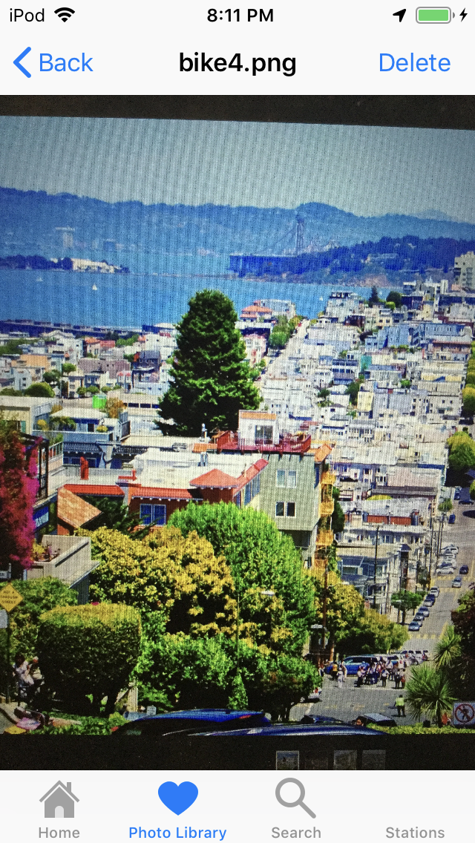

(4.2). When users tap on the photo in Photo Library Collection View, the screen above will be shown. Users can view the larger photo or tap on Delete button to delete the photo. When users tap on Delete button, the app will return to Photo Library Collection View and remove the deleted photo.

**5. Stations:**

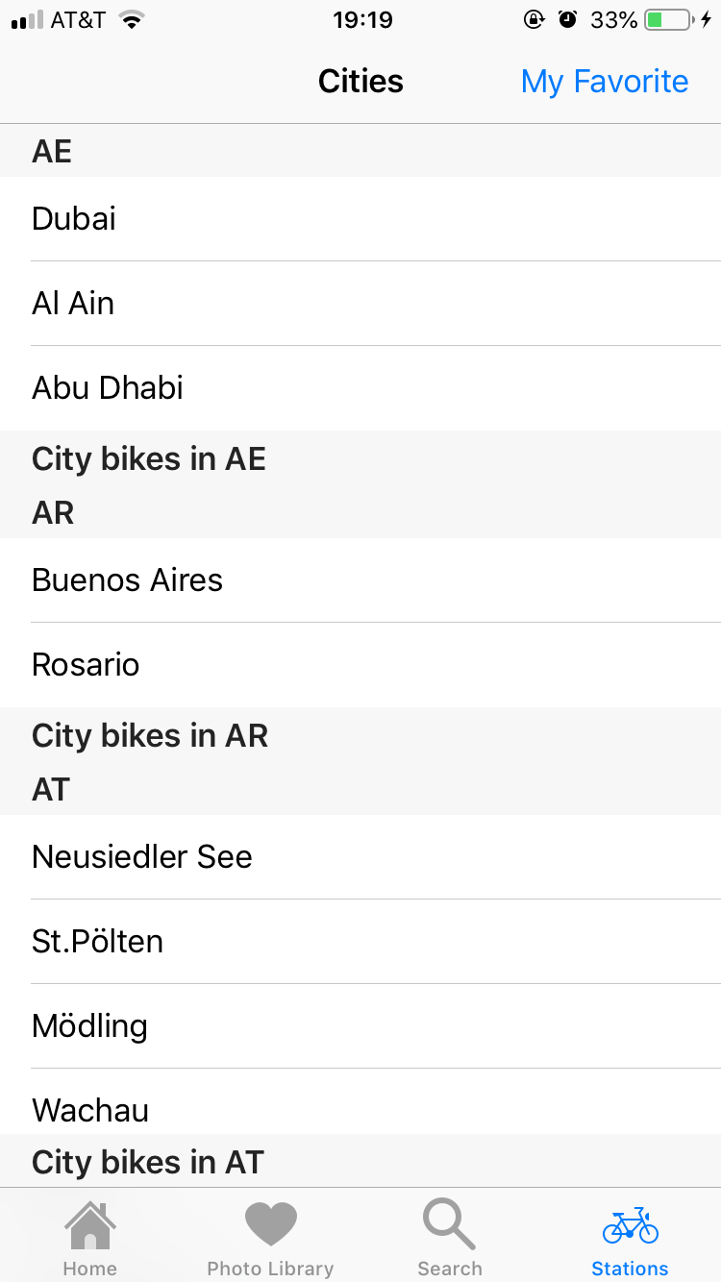

If the user cilcked the fourth tab bar, the stations TVC will be shown. This view is grouped by the country code.

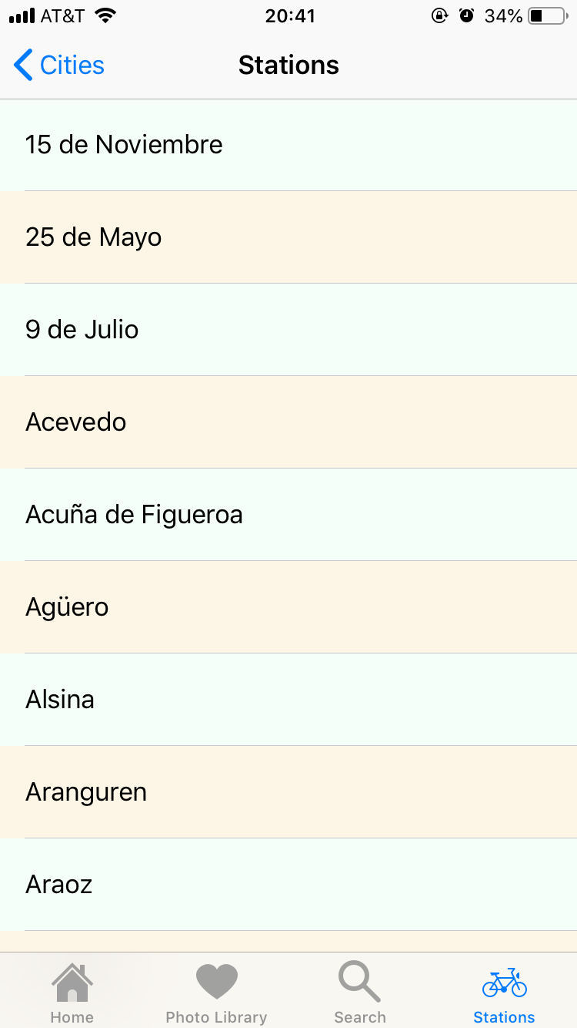

IF the user click a city, it will show the all the stations in the city.

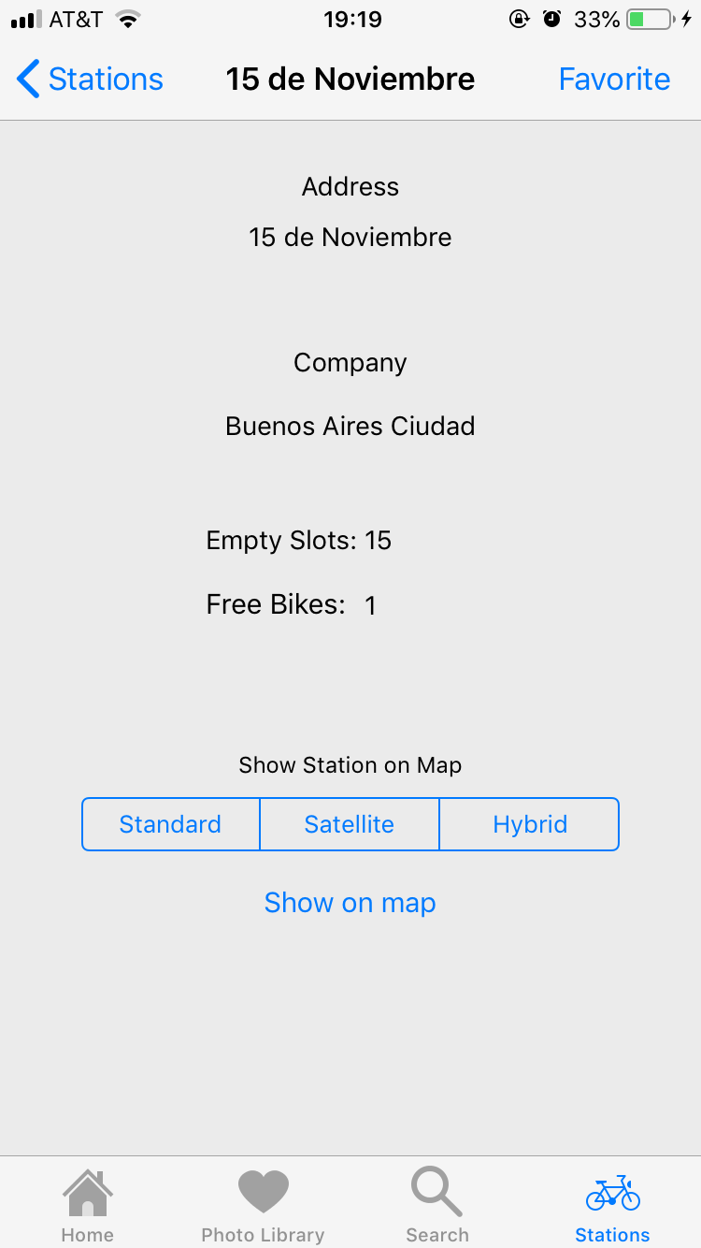

If the user clicked a station, it will show the detail of the station.

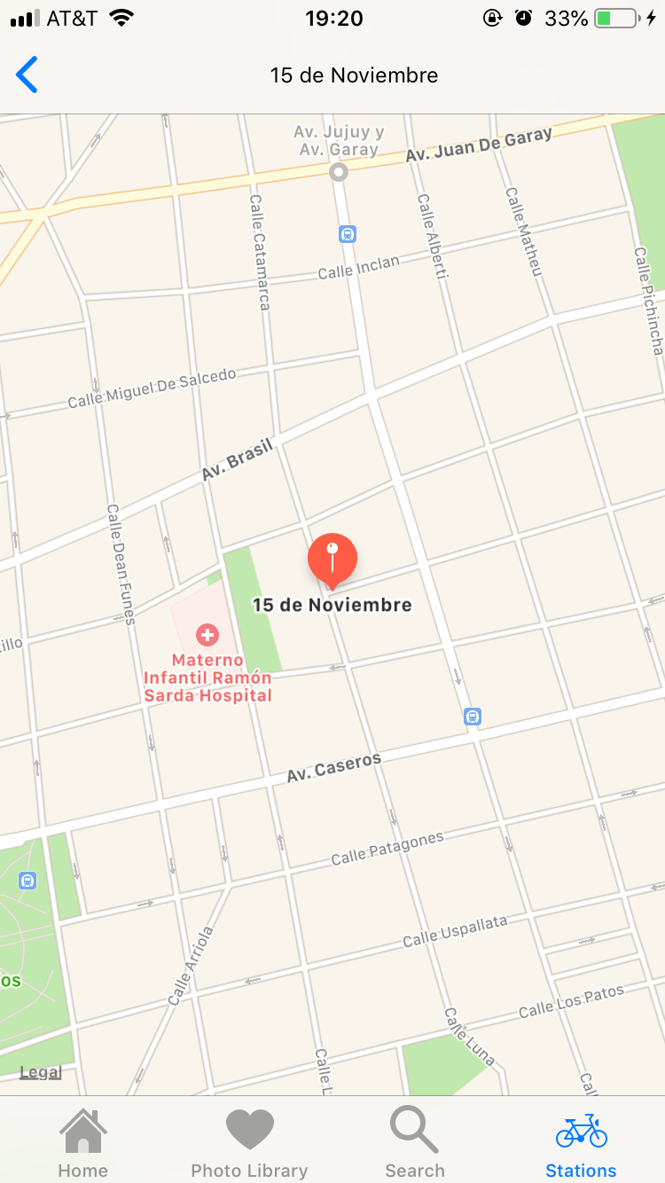

If the user choose a map type and click show on map, the user will see the location of the station.

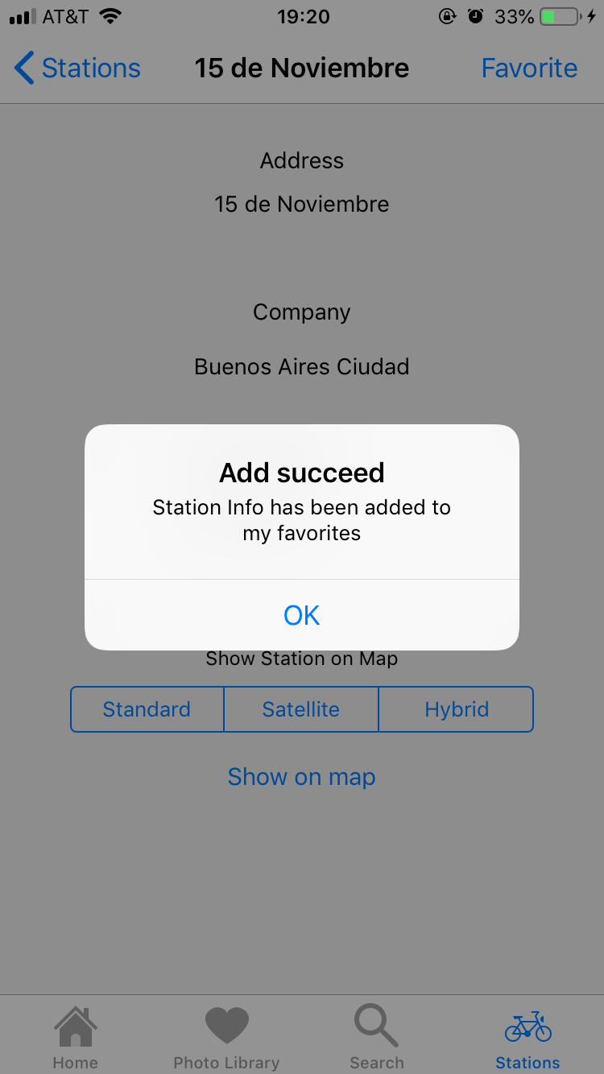

**If the user clicked the favorite button, the station info will be save in the my favorite list.**

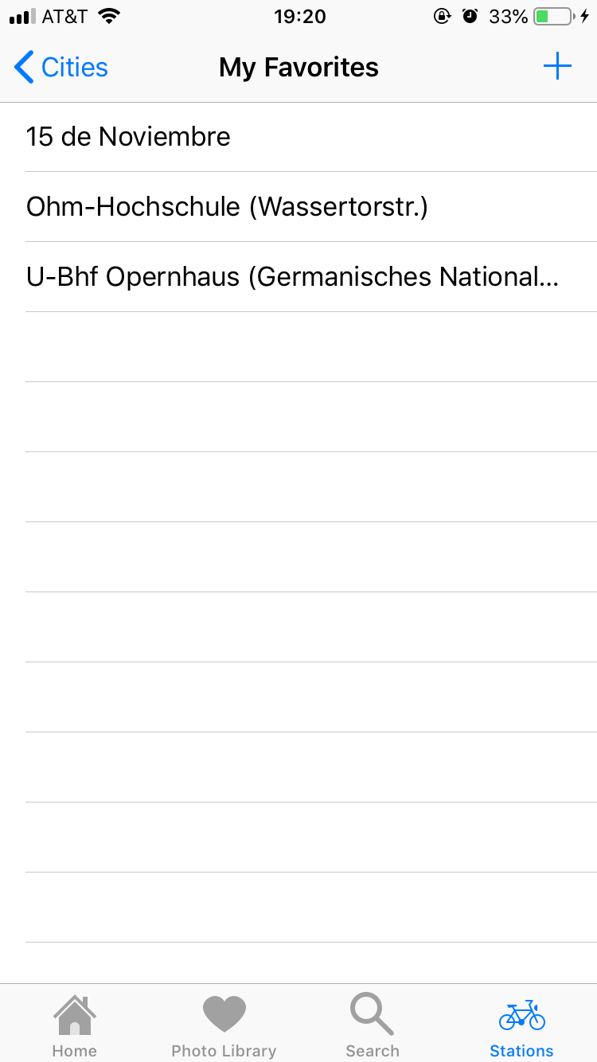

If the user clicked the my favorite bar button, it will show the user the my favorite list.

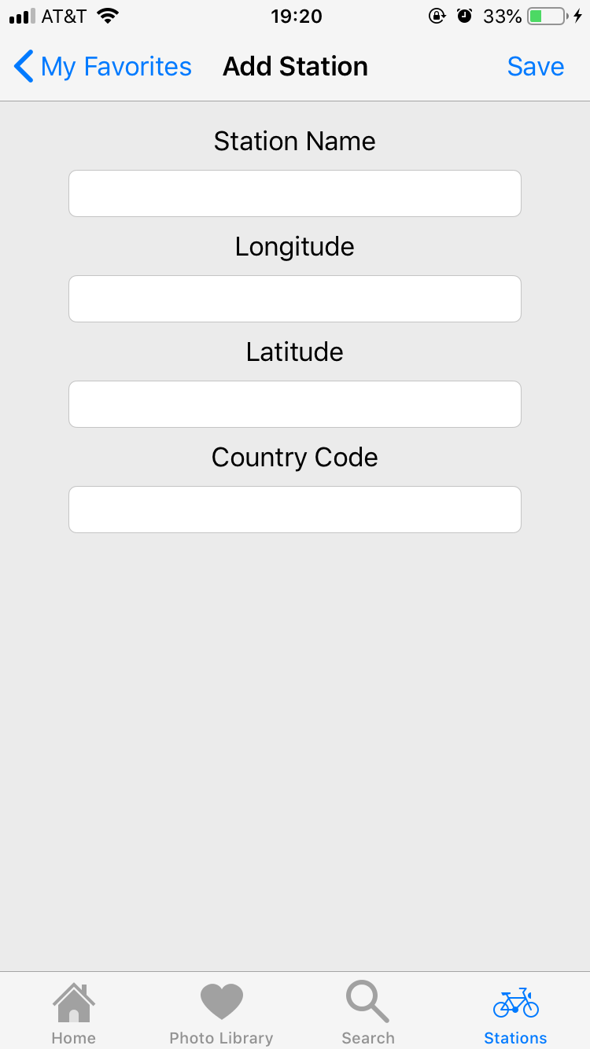

If the user clicks the add button in my favorite list, the user is able to add new favorite station manully. And the user is able to delete a station.

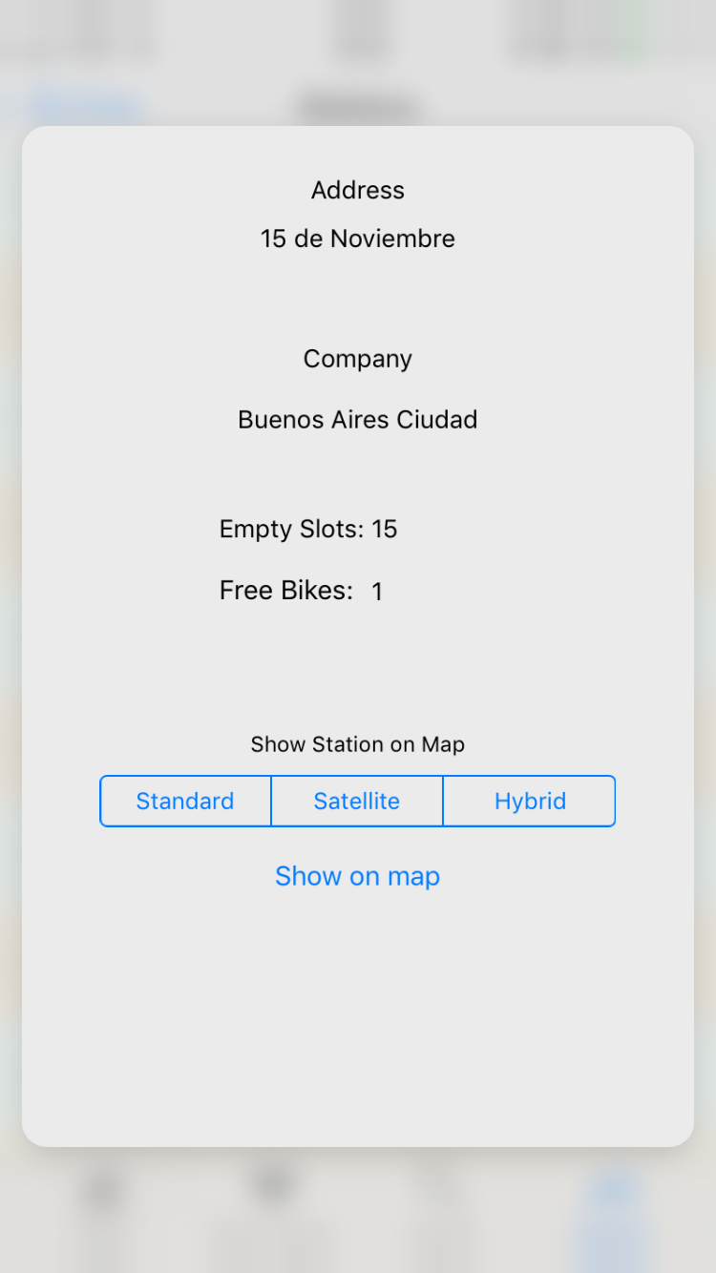

If the user force touching a cell in stations table view, the station detail view will have a preview view. And the user touch harder, the user is able to move to the detail view directly.

# STEP-BY-STEP INSTRUCTIONS FOR DEVELOPING NEW FEATURES

## New Feature 1: 3D touch on Cell

1. 3D touch features are used in table view controllers

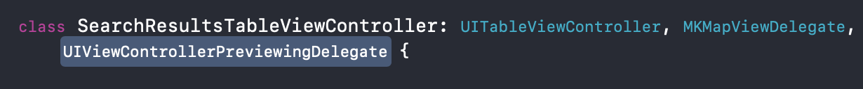

2. Implement delegate first to class header

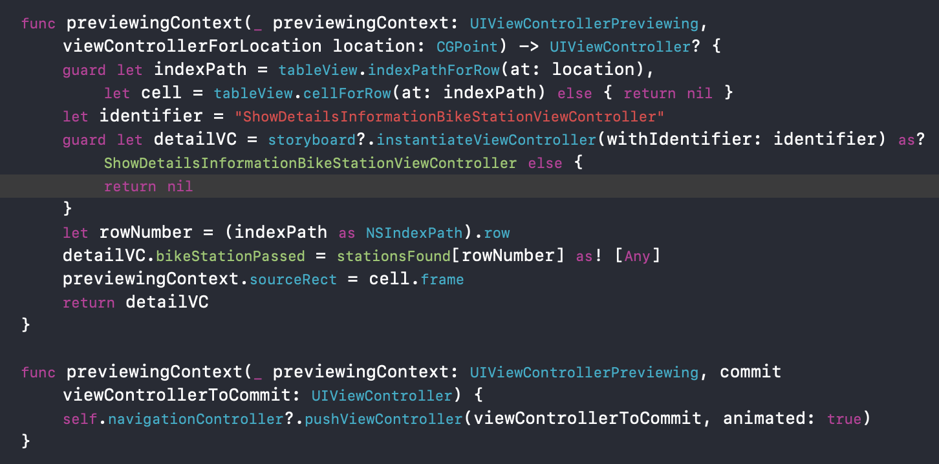

The delegate has two functions: previewingContext, the first one handle the preview function. In order to know which cell is selected, we need to know the rowNumber first, the row numbe rcan be get by indexPath from the function parameter.

Based on the rowNumber, we can know the which data to pass to the next view.

The second function handle the peek and pop function. If the user touch harder, the next view will pop up. The second function will be call by the first one in the background.

## New Feature 2: Collection View

In our CitiBike app, we have implemented Photo Library using Collection View. In the Photo Library, users are able to re-arrange photos by clicking and holding the photo and dragging the photo to the desired cell. Secondly, users are able to Add new photo by tapping on “+” button (4.1), users can take a photo and save photo to display it on the Photo Library Collection View. Moreover, users are able to view the larger photo by tapping on the photo (4.2). On the enlarger photo screen, users can view a larger photo or delete the photo.

How to develop the Collection View:

1. In Storyboard:

* Create a Collection View Controller and two View Controller

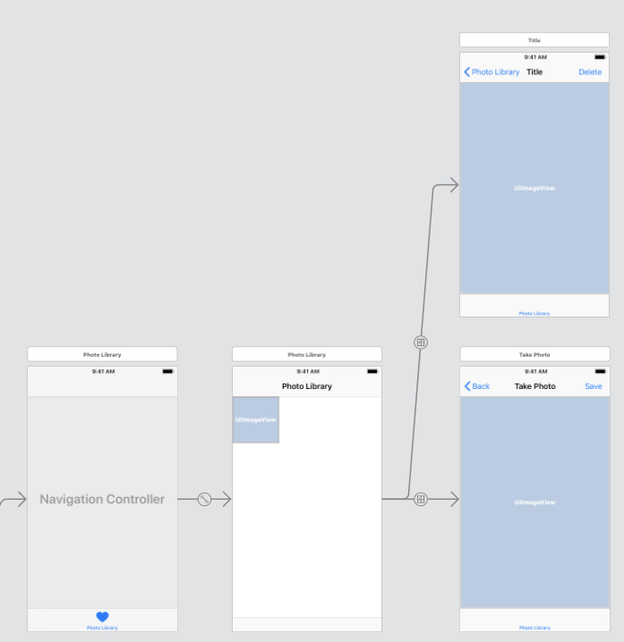

2. We create two files:

+ UICollectionViewController file

+ UICollectionViewCell file to implement code

3. Implementation:

+ Functions to display photos on Collection View

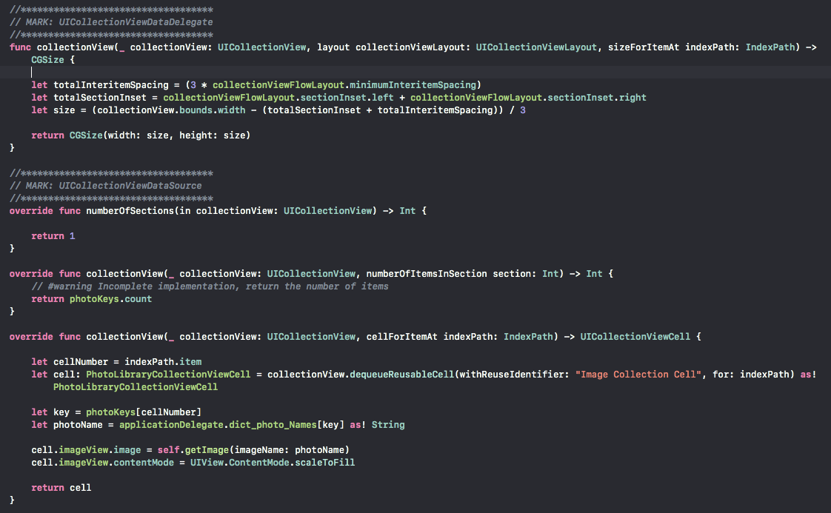

+ The function to re-arrange photos on the Collection View, we are using Gesture

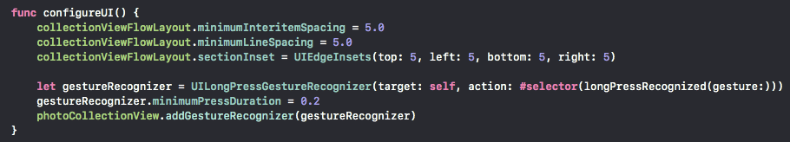

* the function to implement gesture

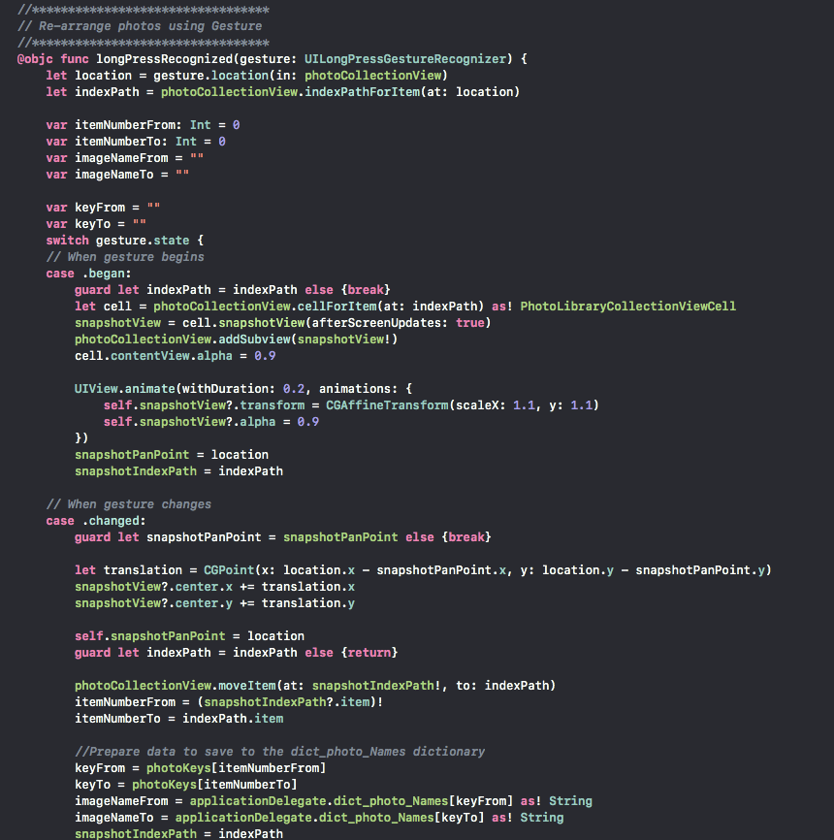

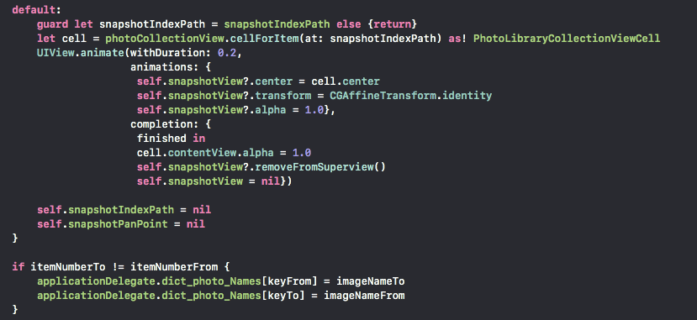

## New Feature 3: Take a Photo, Store, and Retrieve it from the Document Dictionary

In the Photo Library, users are able to take a photo by tapping on “+” button. Tapping the button, a camera will be opened and allow users to take a photo. When users have taken a photo, they can choose to retake or use that photo. If users choose to use that photo, users tap on the Save button to save that photo to the document directory.

How to develop this iOS new feature:

1. On storyboard

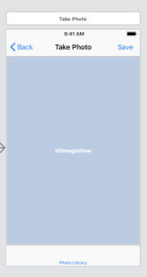

1. Swift files: TakePhotoViewController as View Controller
2. Implementation:

+ In “TakePhotoViewController” implements the function that allow users to take a photo.

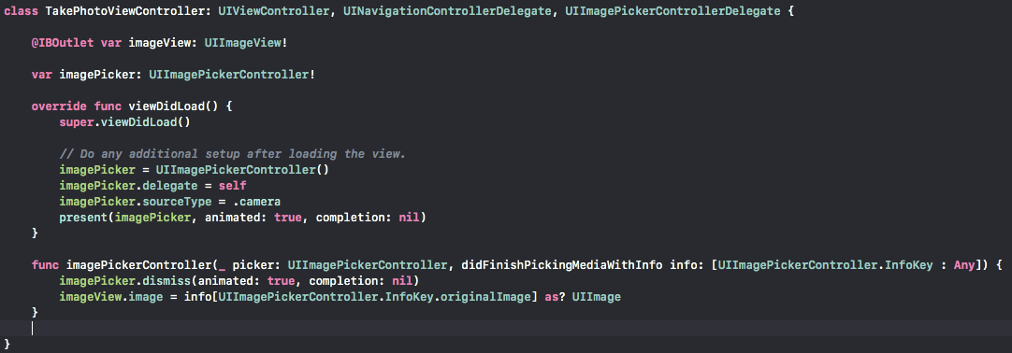

* In “PhotoLibraryCollectionView” implements the functions to save the photo to Document Directory, and rotate image before saving.

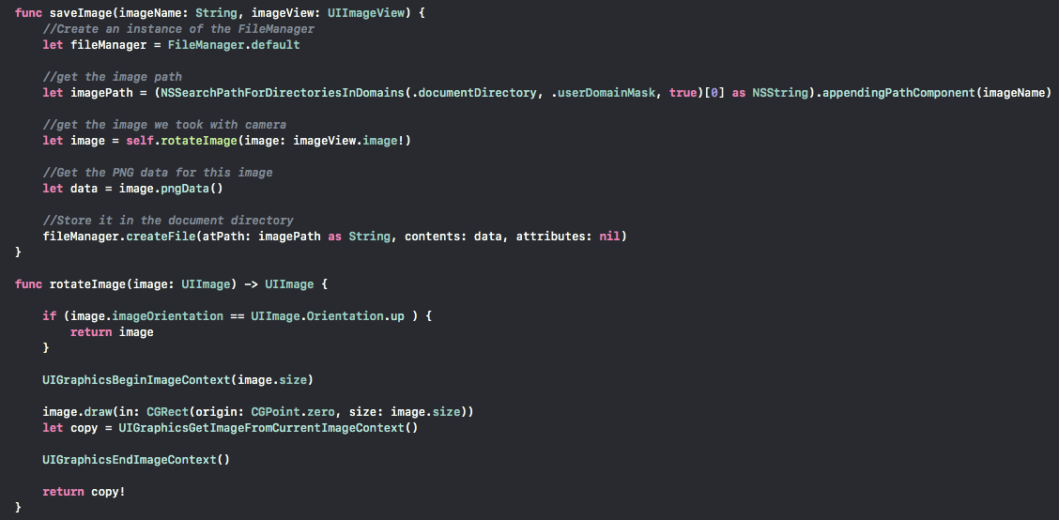

* Get image to display on Photo Library Collection View:

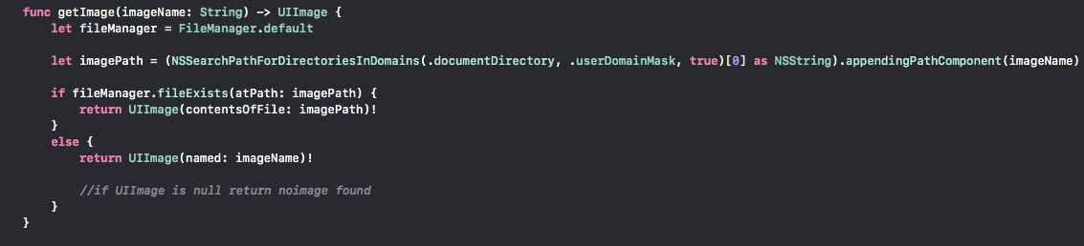

## New Feature 4: Biometric ID

1. The faceId and touch id function can be applied when launch the app.

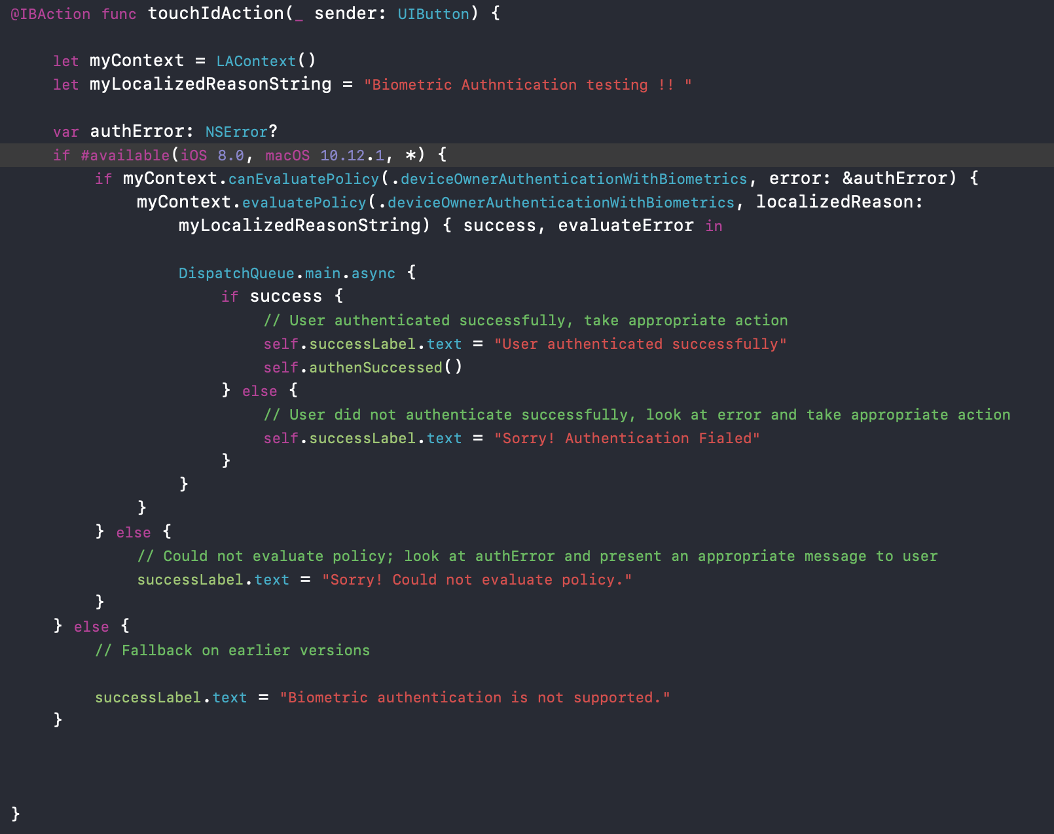



The biometric features are based on the LocalAuthentication dependency.

First, create a LAContext variable first, this variable will be used when we check the user have biometric info stored in the device. The function canEvaluatePolicy and evaluatePolicy will check whether the device owner has the authentication info, such as the touch and Face Id.

Then we need to let the user input the biometric data, simply put the finger on or look at the camera. If the fingerprint or face is matched to the data in the device memory. The authentication passed. Otherwise the warning will be shown.

# CONCLUSIONS

This project gave us a chance to learn and implement many functions in iOS. Even though it is challenge project, and there are still a lot of room for improvements with the application, we are excited that we have accomplished some concrete result with the project. Finally, it is a great opportunity to work with each other as a team. Anyone of us probably could not have done the project by him or herself.

# SUBMISSION INSTRUCTIONS

Please carefully follow the instructions below in submitting your project:

1. Place this project report file Team N Semester Project Report.docx and Xcode project folder in a folder named TeamN-iOSProject and compress it, where N is your team number.
2. Unzip the compressed file on another computer and make sure that the zip file is properly created. Only zip files are accepted.
3. Upload your zip file to your account in [Google Drive](https://www.google.com/drive/), right click the uploaded file and select **Share** from the pop-up menu, enter [balci@vt.edu](mailto:balci@vt.edu), add a note as CS3714 Team N Project Submission, and click Send before the due date.   
   **Late submissions are not allowed.**
4. If your project iOS app is a multi-user app or an app that requires demonstration to evaluate its functionality, then get an appointment with Dr. Balci **before the due date** and go to his office to give a hands-on demo so that your app can be graded properly.

# PERCENTAGES OF CONTRIBUTION

We hereby certify that the list of contributions and the corresponding percentages of contribution specified below truly reflect the actual contributions of the team members.

(Write your name as your signature)

|  |  |  |
| --- | --- | --- |
| *Student Name & List of Contributions* | *% Contributed* | *Signature* |
| Xueting Feng’s Contributions:   1. Create the stations and cities table views. 2. Implemented the maps and my favorite functions. 3. Creating and drawing the app Icon. 4. Implemented detail View for stations. 5. Implemented country grouping and data modifying functions. | 33.3% | Xueting Feng |
| Thoang Tran’s Contributions:   1. Implement Home screen: read JSON data and display bike stations on the map 2. Implement Photo Library: display photos on Collection View, rearrange photo locations on collection view, view larger photo, add and delete a photo 3. Implement taking a photo, store and retrieve it from the app’s document directory on iOS device 4. Implement search bike stations based on the input text file. 5. Implement read Coord JSON data and display the results on Table view. Show bike station details and the travel path between 2 places on the map | 33.3% | Thoang Tran |
| Zhiyuan Li’s Contributions:   1. Implemented the 3D touch function. 2. implemented the faceId and touch Id function. 3. Implemented the Json parsing function 4. Creating dictionaries for the Json data. 5. Debugging and testing. 6. Relate the third party dependencies | 33.3% | Zhiyuan Li |
| Sum of Percentages: | 100% |  |

# CALCULATION OF GRADES BASED ON PERCENTAGES OF CONTRIBUTION

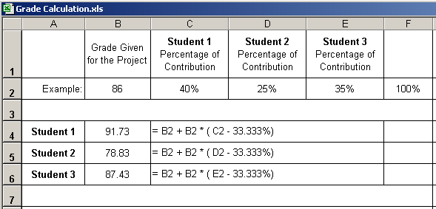

**Additional percentage of contribution cannot exceed 10%.**

**If a situation arises where a student is doing more than 10% extra work, Dr. Balci must be informed immediately.**

# TEAM PROJECT REQUIREMENTS

1. Each team member is expected to contribute equally.
2. You shall submit percentages of contribution together with a list of each student’s individual contributions with signatures of all team members. In case of disagreement, you shall submit it separately with your rationale. (Write your name as representing your signature.)
3. Grades shall be determined based on the percentages of contribution.
4. If you contribute more than your equal share, then your grade shall be increased based on the extra percentage of contribution, which cannot be more than 10%.
5. If you contribute less than your equal share, then your grade shall be decreased accordingly.
6. The extra percentage of contribution shall not be more than 10%. Dr. Balci shall be notified immediately if a situation arises where a student needs to contribute more than 10% extra.
7. A team member who does not cooperate with other team members for conducting the project with equal contribution shall be penalized. Doing more work than agreed upon by the team and claiming extra contribution shall not be acceptable. Cooperation is essential!

# GRADING SHEET

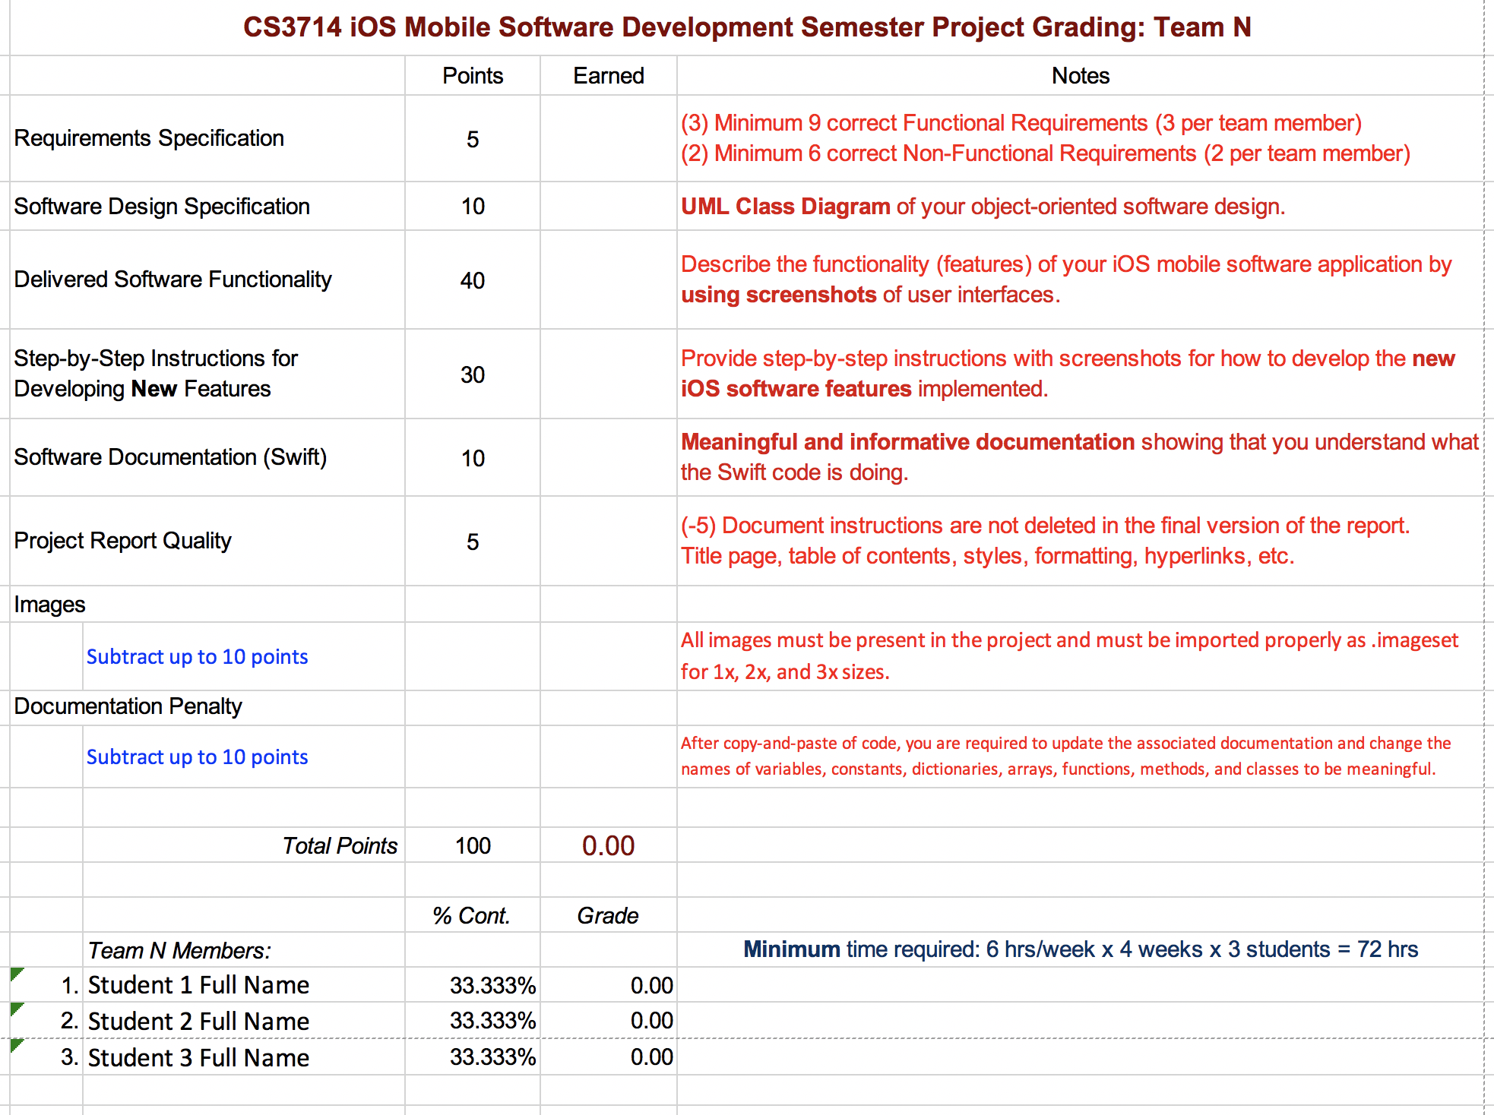

**REFERENCES**

Apple, Inc. (2017), “iOS Developer Library,” <https://developer.apple.com/library/ios/navigation/index.html>

Balci, O. (2016), “CS3714 iOS Mobile Software Development Course Website,” <https://manta.cs.vt.edu/cs3714>

**APPENDIX A: MEETING MINUTES**

**Meeting Number 1**

|  |  |
| --- | --- |
| *Date & Duration:* | October 30th 14:00 - 15:20 |
| *Location:* | 1010 Torgersen |
| *Members Present:* | Thoang Tran, Xueting Feng, Zhiyuan Li |
| *Members Absent:* | N/A |
| *Discussions:* | The function and non-functional requirement and the content for our first presentation. |
| *Decisions Made:* |  |
| *Work Assignments:* | The first presentation |
| *Minutes Prepared By:* | Thoang Tran |

**Meeting Number 2**

|  |  |
| --- | --- |
| *Date & Duration:* | November 06, 2018 14:00 - 15:15 |
| *Location:* | 1010 Torgersen |
| *Members Present:* | Thoang Tran, Xueting Feng |
| *Members Absent:* |  |
| *Discussions:* | Working on User Interface and UML, and the second presentation |
| *Decisions Made:* |  |
| *Work Assignments:* | The second presentation |
| *Minutes Prepared By:* | Thoang Tran |

**Meeting Number 3**

|  |  |
| --- | --- |
| *Date & Duration:* | November 13, 2018 14:00 - 15:15 |
| *Location:* | 1010 Torgersen |
| *Members Present:* | Thoang Tran, Xueting Feng, Zhiyuan Li |
| *Members Absent:* |  |
| *Discussions:* | Begins coding and how to collaborate the function implementation using Github |
| *Decisions Made:* |  |
| *Work Assignments:* | Implement functions |
| *Minutes Prepared By:* | Thoang Tran |

**Meeting Number 4**

|  |  |
| --- | --- |
| *Date & Duration:* | November 27, 2018 14:00 - 15:15 |
| *Location:* | 1010 Torgersen |
| *Members Present:* | Thoang Tran, Xueting Feng, Zhiyuan Li |
| *Members Absent:* | N/A |
| *Discussions:* | Discuss about functions implementation and working on final report |
| *Decisions Made:* |  |
| *Work Assignments:* | Function implementation |
| *Minutes Prepared By:* | Thoang Tran |

**Meeting Number 5**

|  |  |
| --- | --- |
| *Date & Duration:* | December 02, 2018 14:00 - 16:15 |
| *Location:* | 1010 Torgersen |
| *Members Present:* | Thoang Tran, Xueting Feng, Zhiyuan Li |
| *Members Absent:* | N/A |
| *Discussions:* | Discuss about how to parsing the api |
| *Decisions Made:* |  |
| *Work Assignments:* | Function implementation |
| *Minutes Prepared By:* | Thoang Tran |